Council Roadside Reserves Project
  - Asset Management Plan Template
  - for Roadside Trees

Integrating Natural Asset Management into
Council Asset Management Systems

Document Tracking
Version No. | Document Author | Reviewed By | Approved By | Last Saved on

Acknowledgements
This document was prepared by Cardno (NSW/ACT) for local councils in NSW as part of the Local Government NSW (LGNSW) Council Roadside Reserves Project (CRR). The CRR project is funded by the NSW Environmental Trust to build the capacity of councils and to improve the management of roadside environmental values in NSW.
November 2019

Cover: Roadside Vegetation in Oberon LGA (Photo: CT Environmental)
This project has been assisted by the New South Wales Government through its Environmental Trust.

Guide to this document
The intention is that land managers will work directly into a copy of this template. Instructions and prompts are in grey text boxes. These should be deleted as you work through the template. The text in red is for guidance purposes only. Additional background and guidance information is provided in green text boxes.
Some standard wording is provided which can be amended based on the need of the project. Deviations and changes to the suggested AMP structure and contents can be made, as necessary, to suit existing Asset Management Systems.
The guidance in this AMP template is for guidance purposes only and the author should undertake his/her assessment of the asset management needs of the roadside sites covered by the AMP.
The AMP should be completed by an informed person with knowledge of asset management and roadside reserves.

Context
This document has been developed to provide NSW councils with a template to assist them in writing a Roadside Tree Asset Management Plan (AMP). The overall aim of the document is to help integrate the management of roadside reserve trees (roadside trees) into pre-existing Asset Management Systems (refer Figure i), which are generally dominated by built assets.
This template should be used where the assets are standalone trees rather than bushland or riparian vegetation. Trees may be native or non-native and may have ecological, amenity, landscape, cultural or heritage value. Where the trees form part of a plant community with shrub and grass layers over a larger area it may be more appropriate to use the Asset Management Plan Template for Roadside Vegetation.
The production of a quality roadside tree AMP may necessitate the initial collection of a large volume of data and information to inform various sections of the AMP. While the initial data collection process may require effort, undertaking this work upfront will lead to long term benefits and will also reduce the updates required in future versions.
This AMP template is specific to the asset management of roadside reserve trees. It may be possible to apply this AMP template to other trees but the specifics of the guidelines are focussed on those growing in the roadside reserve.
An AMP is a tactical level document focused on a specific asset class or group. The objectives of an AMP are to provide the following:
    - A direct line of sight from the organisational objectives to the specific Levels of Service.
    - A clear description of the assets included within the plan, including the boundaries, what these assets do and how this is important.
    - Specify the measurable Levels of Service the asset must satisfy in order to deliver the higher level asset management objectives and business objectives.
    - Define the life cycle strategies including the arrangements for planning, acquisition, operation, maintenance and disposal of the asset.
    - Develop a budget based on asset needs with a comparison of the allocated resources and highlighting any gaps.
    - Identify risks to the achievement of the Levels of Service over the long term, as well as outlining management strategies
    - Define actions to close Level of Service gaps and control risks, including timeframes and resources
An AMP is informed by the higher-level strategic documents within the asset management system, including the Strategic Asset Management Plan. In addition, the AMP informs the budgeting process for an organisation by providing an evidence based forward works program.

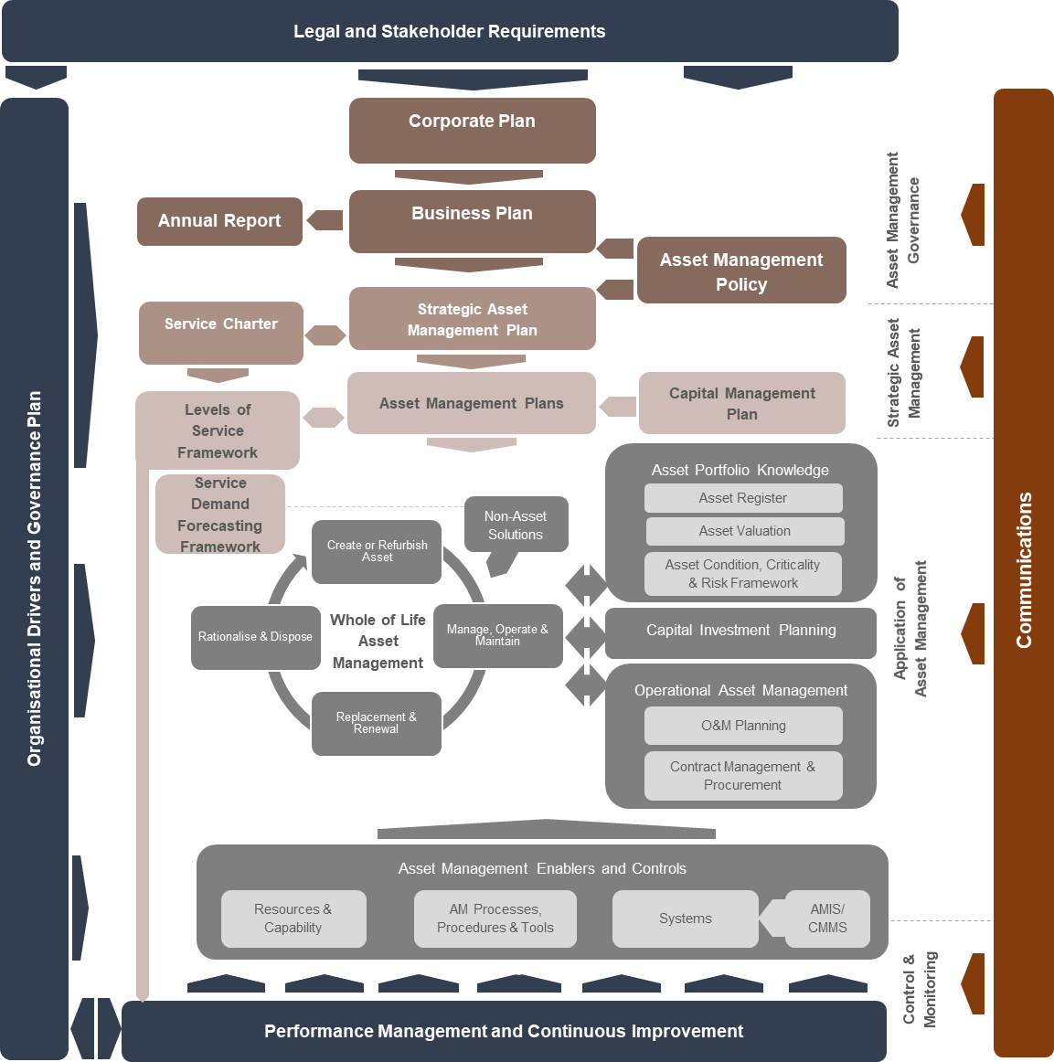
Figure (i): Typical Asset Management System

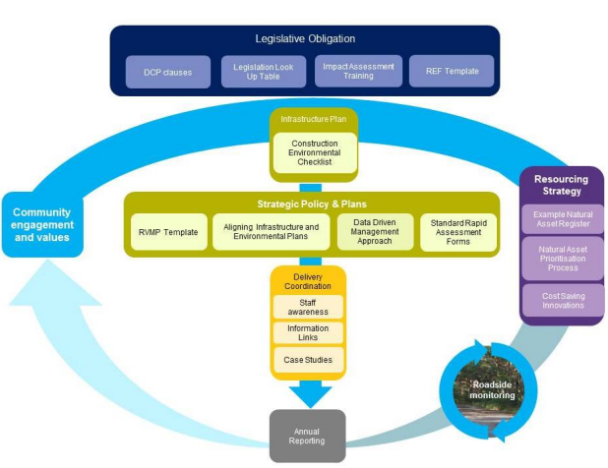

Figure (ii): Asset Management Planning in the Context of the Roadside Environmental Management Framework
There is also a need to align natural assets with built assets through councils’ Integrated Planning and Reporting (IP&R) framework and in particular, through the asset planning process. This is demonstrated in Figure (ii) above.

Asset Management Plan Recommended Structure
The following table of contents is provided to guide the writing of the roadside tree AMP. By following the recommended structure, a robust plan that delivers organisational objectives that are linked to asset management objectives will be produced. Data and information may need to be collected by council to ensure all sections can be completed. Deviations from the recommended structure can be made to suit pre-existing Asset Management Systems and AMPs.

Insert logo

Council Name

Asset Management Plan for Roadside Trees

Prepared by:

Date:

Contents
1. Summary 3
1.1. Purpose of this Asset Management Plan 3
1.2. Objectives and Goals of this Asset Management Plan 3
1.3. Stakeholders 4
2. Introduction 5
2.1. Background 5
2.2. Community Consultation 5
3. Portfolio Summary 6
3.1. Council Snapshot 6
3.2. Description of the Assets 6
3.3. Heritage Assets 8
3.4. Assets with Highest Consequence of Failure and Risk Rating 8
3.5. Asset Condition 8
3.6. Asset Valuation 9
3.6.1. Valuation methodology 9
3.6.2. Asset Useful Lives 9
3.6.3. Valuation data 10
4. Demand 11
4.1. Demand Impacts on Assets and Services 11
4.2. Environmental Issues and Climate Change 11
4.3. Demand Drivers, Projections and Impacts on Services 11
4.4. Demand Management 13
5. Levels of Service 14
5.1. Stakeholder Expectations 14
5.2. Strategic and Corporate Goals 14
5.3. Legislative Requirements 14
5.4. Current Levels of Service 15
5.5. Desired Levels of Service 15
5.5.1. Customer Levels of Service 16
5.5.2. Technical Levels of Service 17
5.5.3. Conservation Levels of Service 18
6. Lifecycle Management 19
6.1. Risk Management 19
6.1.1. Risk Issues 19
6.1.2. Critical Assets 19
6.1.3. Asset Management Decision Making 19
6.1.4. Lifecycle Decision Making Criteria 19
6.2. Planning and Acquisition 21
6.3. Operations and Maintenance 21
6.3.1. Heritage Asset Maintenance 21
6.4. Renewal 21
6.5. Rationalisation and Disposal 22
7. Financial Summary 23
7.1. Long Term Financial Sustainability 23
7.2. Existing Budgets 23
7.3. Planning, Acquisitions, Operations, Maintenance and Renewals Forecast 23
7.4. Funding Gap 24
7.5. Closing the Gap 24
8. Improvement Program 25
8.1. Future Improvement Actions 25
8.2. Asset Management Plan Review 25
9. References 26
10. Appendices 27

List of Tables
Table 1: Hierarchy for natural assets 6
Table 2: Assets covered by this Asset Management Plan 7
Table 3: Location of roadside tree sites covered by this AMP. 7
Table 4: Valuation data including replacement value for each tree asset. 10
Table 5: Demand drivers, projections and potential impacts on services. 12
Table 6: Demand management plan 13
Table 7: Legislative Requirements 15
Table 8: Customer Levels of Service 16
Table 9: Technical Levels of Service 17
Table 10: Conservation Levels of Service 18
Table 11: Long term sustainability targets 23
Table 12: Existing budget for roadside tree assets 23
Table 13: Forecast budget needs for roadside trees 24
Table 14: Future improvement actions 25

Summary
Provide a brief overview of the council as an organisation and of the asset group. In this case the asset is roadside reserve trees. This allows the reader to gain an understanding of the context of the organisation and the assets.
A summary of asset performance and key issues/ risks to the asset group can also be provided in this section.

Purpose of this Asset Management Plan
Outline the value of an AMP in achieving council and organisational objectives. This section can show where the document sits within a wider Asset Management System document hierarchy.

Objectives and Goals of this Asset Management Plan
List the objectives and goals of the AMP.
The objective of the AMP is to show that the assets within the asset class positively contribute to the delivery of council and organisational objectives. This should be linked with the asset management objectives if higher level documents exist in the Asset Management System, e.g. Strategic Asset Management Plan.
For example,
‘The objective is to establish a document to guide the planning, creation, construction, maintenance and operation of the roadside vegetation assets for council to provide services to the community while conserving the valuable asset’. (Muswellbrook Shire Council)
The goals relate to the asset outcomes to be delivered through the AMP.

LGNSW has developed the Council Roadside Environmental Management Framework (CREMF), which aims to streamline roadside environmental management in councils. The framework looks at councils' many complex road responsibilities holistically and aims to support councils in NSW to navigate complex legislation, meet regulatory requirements, minimise risk and make the process of improving roadside environments more efficient and cost-effective.
Embedding roadside environmental management within councils’ management framework (IP&R) has the benefit of streamlining the process by linking it with existing planning, reporting and asset management processes. This is the rationale for identifying the trees in roadside reserves as an asset.

The NSW Roadside Environment Committee has also produced a range of documents focused on planning and managing roadside and other linear reserves. These publicly available documents provide useful guidance in defining objectives and goals for managing linear reserves, as well as providing advice on management strategies. Many councils may have already developed roadside environmental management plans that would assist in finalising the roadside tree AMP.

Stakeholders
Internal stakeholders for the roadside tree sites, include:
List the key stakeholders to the assets, particularly internal stakeholders. Their interest in the assets can be further elaborated here. The following may be applicable:
  - Councillors
  - Asset managers
  - Environmental scientists/ managers
  - Weed officers
  - Roadside maintenance crews
  - Compliance officers
  - Planners
  - Subject matter experts
  - Emergency management staff
  - Financial Managers

External stakeholders include, but are not limited to:
  - Adjacent landowners
  - Regulators
  - Special interest groups
  - Emergency services
  - Landcare groups
  - Transport for NSW (incorporating the former Roads and Maritime Services)
  - Utilities
  - Biodiversity Conservation Trust
  - NSW National Parks and Wildlife Service (NPWS)
  - NSW Department of Planning, Industry and Environment (DPIE; formerly the NSW Office of Environment and Heritage)

Introduction

Background
Put the AMP in context with other relevant council strategic, financial and planning documents. List the relevant documents and provide commentary on their relationship to the AMP.

Community Consultation
Where community consultation has been undertaken to develop the AMP (particularly levels of service and forward works costs) summarise the outcomes and main points.
Otherwise, indicate that the AMP has been prepared to facilitate future community engagement.

Portfolio Summary

Council Snapshot
Provide a brief description of the council area characteristics, using any relevant maps or figures. The snapshot should set the asset into the context of the council area. For example:
  - Length of road corridor
  - Primary industry in the area
  - Demographics
  - Climate
  - Unique features, etc.
This section could also state the importance of roadside trees to the council area/ local context.

Description of the Assets
Provide a more detailed description of the asset in this section.
To set the asset in context, include a table to show the asset hierarchy adopted for the natural asset class (this could be removed as natural asset AMPs mature over time). The generally accepted hierarchy for natural assets is shown in Table 1 below.

Table 1: Hierarchy for natural assets
Asset Class | Asset Type | Asset Component | Asset subcomponent
Natural Assets | Vegetation | Roadside reserve  Riparian reserves | Trees  Shrubs  Grasses
 | Trees | Street trees  Roadside trees  Reserves
 | Water ways | Creek  River  Ocean  Estuary  Lake  Wetland  Pond | Riparian edge  Weir  Bed  Water  Bank  Aquatic vegetation

Summarise at a high level the assets covered by the asset management plan. Provide some basic parameters of the asset, such as tree species, location and the estimated replacement value. An example is provided in Table 2.

Table 2: Assets covered by this Asset Management Plan
Roadside | Tree species | Number of trees | Estimated Replacement Value ($)
Whiting Road | Eucalypt | 3 | 3,000
House Rock Road | Eucalypt | 5 | 5,000
Ridgelands Ave | Eucalypt | 1 | 1,000
Cedar Road | Eucalypt | 20 | 20,000
Mango Road | Eucalypt | 6 | 6,000
Roxburgh Road | Eucalypt | 15 | 15,000
Totals |  | 50 | 50,000

Follow this with an explanation on any restrictions on the asset coverage. This will mainly relate to the data set available. For example, there may only be data for a few sites across the council area.
Insert a table locating the roadside trees sites covered by the AMP. Include relevant details for the asset register or data set used, for example, see Table 3 below.

Table 3: Location of roadside tree sites covered by this AMP.
Tree Identification Number | Tree Species | Threatened Species | Road name | Latitude | Longitude
001 | Eucalypt | No | XYZ Road | -32.26352965 | 150.7331107
002 | Eucalypt | Yes | ABC Road | -32.20458224 | 150.7624128
003 | Eucalypt | No | MNO Road | -32.20387066 | 150.7481678

Where more data is available, include:
  - Tree useful life - (derived from historical council data relating to the life of roadside tree assets, or from published data). For other asset classes, useful life is a key input to decision making, particularly predicting the timing of an asset renewal. For roadside trees, this data may not be as useful but may assist in long term planning.
  - Fauna inhabiting or relying on the tree
  - Tree age
  - Health
  - Historic significance
  - Significant Tree Register
  - Presence of hollows

Heritage Assets
Detail any trees that have heritage or cultural value.

Assets with Highest Consequence of Failure and Risk Rating
Complete this section where risk assessment data is available. When assessing the risk of loss of a tree it should be assessed in terms of the effect on other assets, such as embankments and slopes. A tree risk assessment should also identify the opportunities the loss of a tree provides other assets, such as reduction in tree root damage to pavements and underground utilities.
Assets with a high risk rating should have plans in place to manage the risk similar to the mitigation plans developed for high consequence risks. These plans may also include strategies to reduce or eliminate risk, as well as mechanisms to report the risks and the exposure they pose to council.

Assets with a high consequence of failure are likely to be critical assets, but will not necessarily have a high risk score. Due to the impact of the failure, these assets should have mitigation plans or modified maintenance strategies to minimise the risk of failure. It is important to take intergenerational effects into account when considering the risk of failure for roadside trees. The failure may not be apparent in the generation it occurred but may still pose a high consequence.

Asset Condition
Provide a definition or explanation on the current condition of the roadside tree assets, include information on how it was assessed (may vary from council to council) and what the rating means.
Condition description of tree assets could include if available:
  - Disease evidence
  - Tree shape and form
  - Foliage coverage/ density
  - Fire evidence
  - Storm damage

An overall summary of the asset class can be used to inform the current performance against the Levels of Service. Over time, this section can be extended to show how the performance against the measure is trending.

Asset Valuation

Valuation methodology
This section explains the financial valuation methodology applied to create the replacement cost.
Trees and natural assets are important as they contribute to environmental, community and heritage values. However, the valuation provided in this AMP is the financial valuation only and equates to cost of replacement (you may prefer to delete the following and provide your own methodology here).
The generic methodology for deriving the financial value of a tree is:
  - Identify the species of tree
  - Derive the cost of replacement of each tree species by sourcing:
- The cost of a seedling/ sapling of the same tree species. This can be extracted from any recent contracts, from a local supplier, or from an industry source such as Rawlinsons
- The cost of establishing the replacement tree eg removal of old, ground preparation, protection, root protector, watering. This data can be derived from any recent contract, a local contractor or an industry source such as Rawlinsons. Roadside reserve trees may require higher establishment costs due to the stresses of the roadside location (depends on the traffic volumes)
- Labour costs of the tree planting
- Add in a percent for overhead costs of the plant acquisition, preparation and planting. Use 20% if no data is available to assess this
  - The cost of replacement found above for each tree species becomes the unit rate for that tree species
- Estimate the replacement cost by applying the unit rates to the numbers of trees of each species and then adding all the costs together.
The replacement plant, for any tree, has been assumed to be the most mature plant a council can reasonably afford. This will vary from council to council and potentially vary for each location of the tree. Seedling/ sapling has been used to indicate the replacement is not like for like by tree age.

Asset Useful Lives
Detail the asset useful life and remaining useful life, if data is available. Trees are considered to have extensive useful lives. The following is suggested where no other data is available:

Asset component | Useful life
Trees | 80- 200 years

For the replacement of tree assets, the useful life is not required to calculate the replacement cost. Instead, the replacement value can be determined by using the cost of replacing the asset type with the most mature plant available and affordable from local nurseries inclusive of planting costs. Due to the long useful life of a tree, no depreciation is applied over the life of the tree. In this way, the written down value will equal the replacement cost.
A tree may appreciate in value over its lifetime, especially as it grows and continues to provide increased environmental value. However, the cost of replacing that tree, at any stage of its life, remains the cost of a replacement plant (either seed, seedling or sapling or similar tree).
It is anticipated that most councils will replace a tree with the largest sized plant available to ensure the tree survives (or the largest size the council can fund) but a mature tree will not be transplanted to replace the old tree. Large trees are also susceptible to transplant shock, require additional water and are harder to establish.
The exception may be iconic trees that define a roadside or community (for example a tree that sits at the gateway to a town). In this instance, the replacement cost of the tree should be assessed in more detail as full costs of purchase, preparation, transport and planting will be significant.

Valuation data
Valuation data for each species of roadside trees is listed in Table 4 below.
Table 4: Valuation data including replacement value for each tree asset.
Tree Species | Number of trees | Unit rate ($/tree) | Replacement Cost | Accumulated Depreciation ($) | Annual Depreciation ($) | Written Down Value ($)
Eucalypt | 50 | 1,000 | 50,000 | 0 | 0 | 50,000

Demand

Demand Impacts on Assets and Services
Demand for new and enhanced services are managed through a combination of managing existing assets, augmenting existing assets and providing new assets to meet demand and demand management.
Document the demands placed on roadside reserve trees and then derive management strategies to address those demands. The demands identified should be specific to the council area and not a generic listing.

Demand impacts on asset requirements can arise from climate and environmental changes, population growth/decline or changes in regulatory expectations. In the AMP, anticipated changes in demand and their impact on the asset base should be captured, as should relevant mitigation strategies. If there is a large demand on an asset, this can lead to the following:
  - A shorter useful life, as the asset is being consumed at a faster than expected rate
  - Increases in maintenance cycles due to higher than expected consumption

Environmental Issues and Climate Change
Climate change is an important consideration in demand forecasting and asset planning. A change in climate could lead to changes to roadside trees. Factors include:
Choose from the following, or add your own:
  - Increased frequency and severity of phenomena such as extreme rainfall, wind and thunderstorms that have the potential to cause significant damage to natural assets and open spaces. This could result in reduced access to these areas or the requirement to remove fallen debris which is impeding use
  - Periods of low rainfall leading to drought, which could have impacts on the biodiversity of the roadside vegetation area. This may require human intervention to help maintain the area
  - Potential for increase in bushfire intensity and the frequency of bushfires having a direct impact on roadside tree assets through either fire events or pressure to clear/ modify assets for fire protection/ mitigation purposes
  - Increasing temperature in urban areas can increase the demand for green spaces and roadside trees to combat the urban heat island effect

Demand Drivers, Projections and Impacts on Services
The purpose of identifying demand drivers is to identify factors and trends that may influence the way council’s assets are used in the future compared to the present. In identifying demand drivers and projections, the planning horizon should be considered and included as well as any data used, modelling and assumptions. Demand forecasting should be integrated into the development and reviewing of asset management plans and documented here.

Demand drivers to consider for roadside trees include:
  - Legislation, eg Biodiversity Conservation Act 2016
  - Traffic
  - Road maintenance
  - Road and public safety (e.g. clear zones, power lines, playgrounds, etc.)
  - Neighbouring farmland
  - Changes in community expectations
  - Population
  - Demographics
  - Agricultural, mining, industrial activities
  - Seasonal factors
  - Environmental awareness
  - Climate change
  - Economic factors (eg budget or financial constraints)
  - Habitat
  - Corridors

Table 5: Demand drivers, projections and potential impacts on services.
Demand Driver | Present position | Projection | Impact on service
Agricultural activity | Widespread farming areas across the LGA | A reduction on levels of farming activity and numbers of rural residents, particularly in mining areas | Opportunities to regenerate roadside trees and provide improved access and corridor connectivity
Seasonal factors | Reasonably distinguished seasons | Rainfall to decrease in spring and winter but increase in autumn  Number of hot days to increase and the number of cold nights will decrease  Fire danger index to increase in summer, spring and winter | Stress on the vegetation to cope with extremes in temperature and lower rainfalls, plus direct and indirect impacts of fire.

Demand Management
Provide an outline of council’s strategies or activities to influence demand for services and assets. This includes those activities undertaken as part of sustainability initiatives and/ or to avoid or defer required asset investment, this can include non-asset solutions such as changing public access to a treed area.
Using the demands identified in the previous section (Table 5) briefly describe the demand management plans for each in Table 6 below.

Demand management actions should be considered when determining the annual budget request for trees. Some management actions may require ongoing or longer term actions and should feature in all future budget requests.

Table 6: Demand management plan
Demand Driver | Impact on service | Demand Management Plan
Agricultural activity | Opportunities to regenerate roadside trees and provide improved access and corridor connectivity | Identify areas for new or expanded roadside vegetation areas, including trees.  Increase investment in new roadside trees to improve extent and connectivity.
Seasonal factors | Stress on the vegetation to cope with extremes in temperature and changes in rainfall patterns, plus direct and indirect impacts of fire. | Minimise other stresses on roadside trees such as litter and weeds to allow vegetation to improve its resilience to seasonal factors.  Increase connectivity with other roadside tree areas to facilitate species movement.  Maintain all fire breaks (the road) to minimise any fire spreading – including trimming over hanging branches back to the road or verge edge.  Reduce the hazard through controlled burning, mechanical clearing or reduce the ground fuel by hand.  Ensure the Bush Fire Management Plan takes account of the status and ecosystem value of the roadside tree areas.  Limiting access to roadside tree sites during high fire risks periods.

Levels of Service
LoS are defined within the International Infrastructure Management Manual (IIMM) as “what the organisation intends to deliver. Levels of Service define attributes of service from a customer point of view.”

Document the Levels of Service (LoS) council intends to deliver through the assets. There should be line of sight from delivery of LoS through to achievement of Asset Management objectives and ultimately the delivery of organisational objectives.
LoS might be identified from pre-existing Asset Management System documents including:
  - Strategic Asset Management Plan
  - Roadside Vegetation Management Plans
  - Community Strategic Plan
  - Maintenance contract requirements

Stakeholder Expectations
State the current understanding council has of its stakeholder expectations, how stakeholders understand the costs associated with roadside trees providing a service and any completed / planned stakeholder consultation. Stakeholder consultation may be in the form of a community satisfaction survey.

Strategic and Corporate Goals
List the elements of relevant strategic documents that relate to the development of Levels of Service (LoS) for roadside tree asset management. This should include the Asset Management Policy, the Strategic Asset Management Plan and the Community Strategic Plan.

This provides the line of sight from the AMP to strategic guidance. Ultimately if a LoS cannot be aligned with council’s strategic direction the validity of allocating funds to meet the LoS should be assessed in detail.

Legislative Requirements
List the main acts, regulations and codes specific to roadside trees. Typically, these are the minimum service standards. Councils will need to be compliant with all appropriate acts, regulations and codes.

Table 7: Legislative Requirements
NSW Acts | Commonwealth Acts
Biodiversity Conservation Act 2016 | Aboriginal and Torres Strait Islander Heritage Protection Act 1984
Biosecurity Act 2015 | Environmental Protection and Biodiversity Conservation Act 1999
Coastal Management Act 2016
Crown Lands Management Act 2018
Environmental Planning and Assessment Act 1979
Heritage Act 1977
Local Government Act 1993
Local Land Services Act 2013
National Parks and Wildlife Act 1974
Pesticides Act 1999
Protection of the Environment Operations Act 1997
Roads Act 1993
Infrastructure – State Environment Planning Policy

Current Levels of Service
List any current LoS. These are likely to be recorded in any roadside tree maintenance contracts or from the strategic documents identified in the previous section.

Desired Levels of Service
It is desirable to have a sufficient set of LoS statements to encompass all aspects of managing the assets covered within the AMP. Desired Levels of Service have typically been identified but may not have been implemented into the way an organisation manages its assets, including reviewing maintenance activities to ensure the LoS can be achieved.
During the development of an AMP, it is common to identify desired LoS, which may be derived from:
  - Legislative requirements and applicable Australian Standards
  - Stakeholder expectations from research and feedback
  - Strategic requirements

Three types of Levels of Service have been determined:
- Customer Levels of Service -- measure how the community receives the service and whether the organisation is providing community value. Customer level of service measures used in the asset management plan are:
- Quality How good is the service?
- Function Does it meet users’ needs?
- Capacity/Utilisation Is the service over or under used?
These are summarised in Table 8.
- Technical Levels of Service - Supporting the customer service levels are operational or technical measures of performance. These technical measures relate to the allocation of resources to service activities that the organisation undertakes to best achieve the desired community outcomes and demonstrate effective organisational performance. Technical service measures are linked to annual budgets covering:
- Operations – the regular activities to provide services such as data gathering, performance measurement, reporting, management systems (GIS, valuation), etc.
- Maintenance – the activities necessary to retain an asset as near as practicable to an appropriate service condition (e.g. pruning),
- Renewal – the activities that return the service capability of an asset up to that which it had originally or a lower capability if specified in the Levels of Service (e.g. replanting)
- Upgrade – the activities to provide a higher Level of Service (e.g. more mature trees) or a new service that did not exist previously (e.g. new area of roadside trees).
These are summarised in Table 9.
- Conservation Levels of Service – describing the quality of biodiversity (e.g. density of flora and fauna, degree of weed infestation or level of restoration). These are summarised in Table 10.

Customer Levels of Service
In accordance with the definitions above. Table 8 documents the recommended Customer Levels of Service to be achieved for the roadside tree sites.
Table 8: Customer Levels of Service
Service Aspect | Level of Service | Measure | Method of measurement | Target | Current Performance
Safety | Roadside tree facilities are safe to use for intended purpose by maintenance staff, general public etc. | Number of reports of incidents in roadside tree areas | Audit of reported incidents | Decreasing trend in number of reported incidents
Compliance | Ensure all roadside tree assets comply with all relevant legislative and regulatory provisions | Percentage compliance with all Legislative Acts, Regulations and Codes | Periodic specialist inspections | All non-compliant roadside tree assets are on works programs for rectification.  Preventative management actions to avoid inadvertent compliance breach (eg corporate information systems, GIS, marker schemes, geofencing to identify known locations of EEC’s / threatened species habitat.

Technical Levels of Service
Technical measures that are typically internal measures, focus on how the service is provided and parameters around the service. These measures can influence resource allocation and determine the budgets for providing the service to meet the community’s expectations.
Technical measures to consider implementing include:
Table 9: Technical Levels of Service
Service Aspect | Level of Service | Measure | Method of measurement | Target | Current Performance
Maintenance | Roadside tree areas are maintained and managed in accordance with good practice guidelines | Maintenance specifications are reviewed each year and updated in accordance with new good practice guidelines | Audit maintenance specifications against current good practice guidelines | Maintenance specifications reflect good practice guidelines published within the last 24 months
Function | Maintenance and operational risks are recorded and monitored | Council to maintain Risk Register and monitor effectiveness of risk treatments with no asset assessed as extreme | Annual review of risk register | Register maintained and no extreme risks on register for more than one month

Conservation Levels of Service
The recommended Conservation Levels of Service are listed in Table 10.
Table 10: Conservation Levels of Service
Service Aspect | Level of Service | Measure/ Methodology | Method of measurement | Target | Current Performance
Conservation value | Improve conservation value | Establish current conservation value and increase | Assess conservation value every 5 years | Improve conservation value by 5% in 5 years (eg species abundance / reduction in exotic species / bushland extent)
Conservation value | Improve habitat connectivity | Identify key connectivity corridors and establish or repair in priority order | Assess habitat connectivity every 5 years | Improve habitat connectivity by 5% in 5 years
Conservation condition | Protect roadside vegetation from human harm | Conservation condition is not harmed | Field inspection of conservation value | Conservation value does not decrease through harm from human factors.
Conservation condition | Prevent deterioration of conservation condition of roadside vegetation | Conservation condition does not deteriorate | Field inspection of conservation condition | No negative change in conservation condition.

Lifecycle Management

Risk Management
Council’s approach to identifying, evaluating and managing risks is often documented in their risk management framework. Councils will have a corporate risk management process and there may be additional processes to further assess operational or asset specific risks.
Document how a risk assessment is completed for roadside trees, and how this leads to interventions which will be covered in Lifecycle Decision Making Criteria.

Risk Issues
Where a risk assessment of the trees covered by the AMP has been undertaken, list the significant risk issues. This information should be used to determine actions to be funded by capital or operational & maintenance budgets.

Critical Assets
Not all roadside trees may be considered to provide the same service to the community. Some may be identified as critical assets. Any trees that have been identified as critical should be listed here. A higher LoS may be applied to critical trees. Critical trees may be:
  - Providing roadside vistas for traffic entering or exiting a town
  - Iconic to the town or road they are adjacent to
  - A listed threatened tree species
  - Within threatened species habitat
  - Within an Endangered Ecological Community

Asset Management Decision Making
Asset management decision making should be evidence based and relate to criteria in the AMP covered to date. That is:
  - Tree condition and performance
  - Demands on trees and demand management strategies/ actions
  - Levels of Service
  - Risk and criticality
List the decision making criteria used to determine maintenance strategies and funding needs here.

Lifecycle Decision Making Criteria
This section will outline council’s process for managing the asset lifecycle through planning, acquisition, management, renewal and disposal.
The lifecycle decision-making process focuses on optimising the life of the tree assets. The decision-making process through each phase of the lifecycle is outlined below:
- Planning. This involves the identification of need, options analysis and justification of the proposal. This process can include seeking advice from professionals on proposals, etc.
- Acquisition. This is the purchase and planting of the trees based on the decisions made in the planning phase
- Operate and Maintain. The maintenance strategy is to maintain the trees to the relevant standard to meet the LoS. This includes regular inspections, maintenance and reporting. Inspections are to be undertaken to understand where the tree assets are within their lifecycle and their condition to enable adjustment of maintenance regimes where necessary.
- Renewal. Asset condition will deteriorate over a long period of time, depending on asset demand and require a renewal. Renewal often forms a large component of the budget and correct information at this stage of the process is paramount to making cost effective decisions that will deliver the required levels of service.
- Rationalisation and Disposal. Trees have a long asset life if they are maintained adequately and demands managed. However, trees also interact with other assets in the road reserve and may pose safety threats to road users. Disposal of a tree may not be related to the condition or age of the asset if it sits within the road clear zone, its roots are causing pavement deterioration or infiltrating underground services.
The typical asset lifecycle is shown Figure 1.
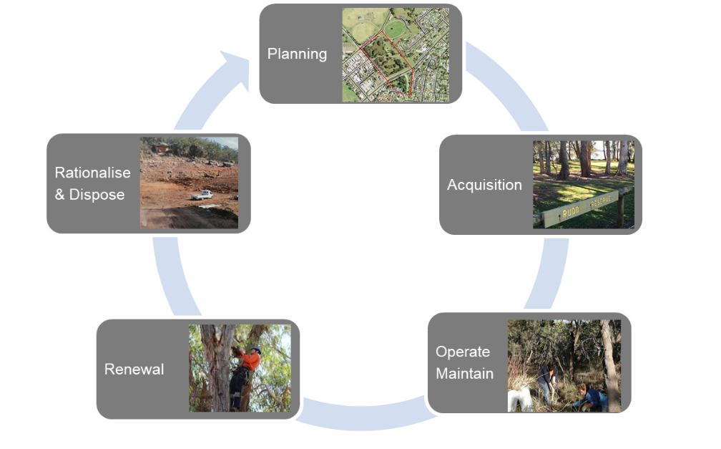
Figure 1: Typical Asset Lifecycle

Planning and Acquisition
Include details on how council identifies new asset acquisition needs, including intervention criteria, how they are assessed including procurement options and who in the organisation endorses those needs and progresses them into the capital program.
The planning and acquisition process should include consideration of:
  - Purpose of the tree in the roadside
  - Road safety clear zone requirements
  - Underground services
  - Neighbouring land
  - Tree resilience in terms of water and soil nutrients
  - Asset resilience in terms of climate change
  - Tree species, including dimensions at maturity
  - Tree resistance to pests and diseases

Operations and Maintenance
Asset specific operations and maintenance include:
  - Asset maintenance strategies
  - Any cyclic/programmed maintenance and operations such as pruning, lopping and watering
  - Existing service providers and the scope of their works
  - Frequencies, high-level description of activities, team responsibility and status (current/not started)
  - Specific requirements when undertaking work on heritage trees
  - Understanding the current backlog, types of backlog and prioritisation of these works, if the data is available. Backlog types include statutory works, accessibility works, refurbishments and other works.

Heritage Asset Maintenance
Identify any maintenance activities that are particular to heritage assets.

Renewal
Describe the process for tree renewals. Many of the considerations will be the same as those for new trees but renewal should also consider:
  - Replacement tree species – it may not be prudent to replace with the same species
  - The balance of the natural assets in the roadside site - what purpose is the tree playing in the roadside?
  - The location the renewal is planed – is the roadside the ideal location?
  - The maintenance regime required for the tree compared to the constraints the roadside reserve site presents.
Any criteria to be addressed before rationalising any assets should be identified and listed.

Rationalisation and Disposal
Outline the disposal strategies for tree assets. Considerations before disposing will include:
  - Legislation – e.g. threatened species
  - Cultural or heritage significance of the tree
  - Habitat provision – should the tree be disposed of, if it offers habitat to fauna?
Disposal strategies may include:
  - Offsetting – if the disposal relates to safety reasons
  - Cutting down and mulching for distribution on other council land
  - Cutting down and chopping for community use (e.g. firewood)

Financial Summary

Long Term Financial Sustainability
List any council long term sustainability targets that need to be considered when determining a budget for roadside trees.

Table 11: Long term sustainability targets
Target Description | Ratio | Calculation | Measure
Sustainability | Operation performance ratio | (Total operation revenue – total operating expenditure) / (Continuing operating expenditure) | >0%
Infrastructure & Service Management | Asset maintenance ratio | (Actual asset maintenance) / (Required asset maintenance) | >100%
Efficiency | Real operating expenditure | (Operating expenditure) / (Population) | Decreasing

Existing Budgets
Detail the existing budget for tree assets by financial year. This might be identified from a council’s operational plan, for example.

Table 12: Existing budget for roadside tree assets
Financial Year (FY) | Planning | Acquisition | Renewals | Operations and Maintenance | Rationalisation and Disposal
2019/20 | $X | $X | $X | $X | $X
2020/21 | $X | $X | $X | $X | $X
2021/22 | $X | $X | $X | $X | $X
2022/23 | $X | $X | $X | $X | $X
2023/24 | $X | $X | $X | $X | $X

Planning, Acquisitions, Operations, Maintenance and Renewals Forecast
Include the forecast budget needs for roadside trees - planning, acquisitions, operations, maintenance and renewals activities. These forecast budget needs should be derived from the requirements identified in previous sections of the AMP, i.e. levels of service, condition, legislation and sustainability targets. Where possible a long term forecast should be included (20 years).

Table 13: Forecast budget needs for roadside trees
Financial Year (FY) | Planning | Acquisition | Renewals | Operations and Maintenance | Rationalisation and Disposal
2019/20 | $X | $X | $X | $X | $X
2020/21 | $X | $X | $X | $X | $X
2021/22 | $X | $X | $X | $X | $X
2022/23 | $X | $X | $X | $X | $X
2023/24 | $X | $X | $X | $X | $X

Funding Gap
Discuss the difference between the existing funding and the forecast budget and what is required to maintain the asset to the desired LoS. Identify and document where the main differences are and provide details of why. For example:
  - New Levels of Service to be implemented
  - Revised Community Strategy with new goals for roadside trees
  - Roadside trees XYZ in poor condition and require revised maintenance strategy
  - Change in legislation

Closing the Gap
Propose options to reduce the funding gap. This may include:
  - Reallocation of funding from other asset classes
  - Applying for XYZ government grant

Improvement Program

Future Improvement Actions
List all improvement actions and prioritise them on a value for effort basis.

Table 14: Future improvement actions
Item | Action Description | Priority  (High/ Medium/ Low)
1 | Confirm full funding allocated to the management of roadside trees from both CAPEX and OPEX allocations. | High
2 | Review the Levels of Service in this AMP and refine as necessary. | High
3 | Initiate a long term data collection program to collect data (on a regular basis) for the measurement of Levels of Service achievement and financial valuations. Identify the frequency interval that best suits the asset type and the likelihood of change in the asset over time (less change over time = less frequent data collection required). | Medium
4 | Assess condition over time to identify any decreasing trends that will require investment to arrest. | Low

Asset Management Plan Review
The AMP is not a static document and needs regular reviews to ensure it remains appropriate in the current operating environment. These reviews should be conducted on an annual basis to:
  - Identify and update any sections where statements are superseded
  - Update the asset class statistics as data systems mature. Compiling asset statistics across the portfolio is a long-term goal but is likely to increase each year as more information becomes available.
  - Update the financial projections for the asset class to monitor long-term expenditure. The process will be similar to updating the asset statistics and can be used to extract measurable performance outcomes related to the recommended service and performance standards.
  - Update and monitor performance against the LoS.
  - Identify where new challenges have emerged over the past year through management of this asset class. Update the improvement program in response to any new challenges and experiences relating to implementation of the actions.

References
List documents and data referenced to build the asset management plan

Appendices
Include any detailed information that supports the asset management plan content. This might include:
  - A greater detail of the roadside tree locations
  - Excerpts from relevant publications
  - Maintenance specifications from relevant contracts
  - Tree Management Plan
  - Tree Policy

